Setting up a Scitek 420 Lock-in amplifier with WinEDR
J Dempster 13/7/9

Connections

Connect the following cables between the patch clamp, Scitek 420 and the laboratory interface analog inputs.

Axopatch 1D
Scaled current output I ( β α mV/pA) | Lab. Interface Analog Input 0
Voltage output (10 Vm) | Lab. Interface Analog Input 1
Gain Telegraph | Lab. Interface Analog Input 7
Unscaled current output I (β mV/pA) | Scitek 420 Input
Scitek 420
X output | Lab. Interface Analog Input 2
Y output | Lab. Interface Analog Input 3
Reference | Signal Generator Output (50Ω)

Signal Generator

Set the frequency to 1.5 KHz, sine wave output. Connect an oscilloscope to the output of the signal generator and adjust the output to 2V peak-to-peak.

Scitek 420 Lock-in Amplifier

Set the following on the lock-in amplifier

Sensitivity | 100 mV
Time constant | 30 ms
Offset On/Off | Off
Phase shift (switch) | 270*
Phase shift (variable) | 85*
2F/1F switch | 1F
* May need adjusted during initial phase setting

WinEDR Setup

Set the following in the WinEDR Recording Setup dialog box (Setup/Recording):
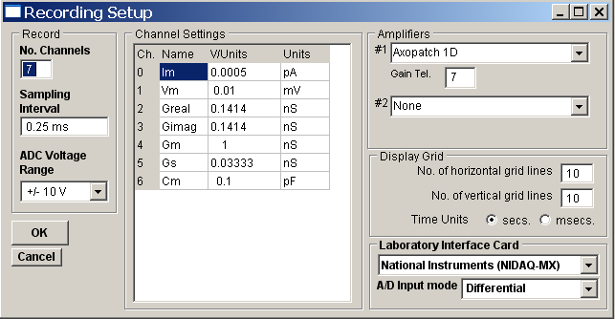
No. channels | 7
Sampling Interval | 0.25 ms
Amplifier | Axopatch 1D or  Axopatch 200
Gain Tel. | 7
Greal V/Units | 0.1414 ⁺
GImag V/Units | 0.1414 ⁺

⁺ Note. Greal and GImag V/Units is correct for a 2V peak-peak amplitude sine wave and a lock-in amplifier sensitivity of 100 mV. If different amplitudes and sensitivities are used, these settings need to be changed. The table below contains the settings for a range of sine wave amplitudes and lock-in amplifier sensitivities.

Lock-in  amplifier  sensitivity | Sine wave peak-peak amplitude
Lock-in  amplifier  sensitivity | 0.25V | 0.5V | 0.75V | 1.0V | 1.25V | 1.5V | 1.75V | 2.0V
Lock-in  amplifier  sensitivity | V/Units | V/Units | V/Units | V/Units | V/Units | V/Units | V/Units | V/Units
1000 | 0.0018 | 0.0035 | 0.0053 | 0.0071 | 0.0088 | 0.0106 | 0.0124 | 0.0141
300 | 0.0059 | 0.0118 | 0.0177 | 0.0236 | 0.0295 | 0.0354 | 0.0412 | 0.0471
100 | 0.0177 | 0.0354 | 0.0530 | 0.0707 | 0.0884 | 0.1061 | 0.1237 | 0.1414

Setting the lock-in amplifier phase shift.

- Remove any electrode holder/model cell from patch clamp head stage.
- Connect an oscilloscope to the lock-in amplifier front panel output and set the output select switch to X.
- Set all patch clamp capacitance compensation dials to zero.
- Twiddle the Fast Mag capacitance compensation dial by 90 units back and forth and observe the resulting displacement of the X signal. Adjust the phase shift setting on the lock-in amplifier until no displacement in the X signal occurs when the dial is moved.

Patching and recording from a cell

- Set Axopatch low pass filter -3dB FREQ. switch to 10 kHz.
- Use JUNCTION NULL to set the membrane current to zero with electrode in bath.
- Patch a cell and when in cell-attached mode, apply a test pulse and compensate for pipette capacity using the FAST MAG dial.
- Break in to cell and compensate for cell capacity using the SERIES RESISTANCE and WHOLE CELL CAP compensation dials. Note down dial settings.
- Adjust the cell holding potential to the resting potential of the cell.
- Set the Axopatch low pass filter -3dB Frequency to 50 Hz.
- Set the Axopatch current gain to X10.
- Open the WinEDR recording window (Record/Record to Disk) and tick the Capacity special option to start capacity measurement.
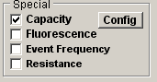
- Click the Config button to open the Computed channels configuration window
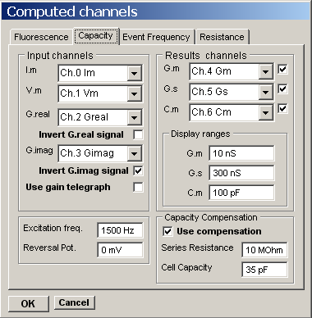
Tick the Invert G.Imag signal option.
Set Excitation freq = 1500 Hz
Set Series Resistance = Axopatch SERIES RESISTANCE setting.
Set Cell Capacity = Axopatch WHOLE CELL CAP setting.
Set Reversal Pot. = ?? mV
Tick the Use Compensation option,
Click the OK button to select settings.
- Create a new data file (File/New), set Duration = the required recording time (e.g. 200s) , and click Record to starting recording.

